* **Session Impersonation**

1. **Open firefox and click on option application menu**

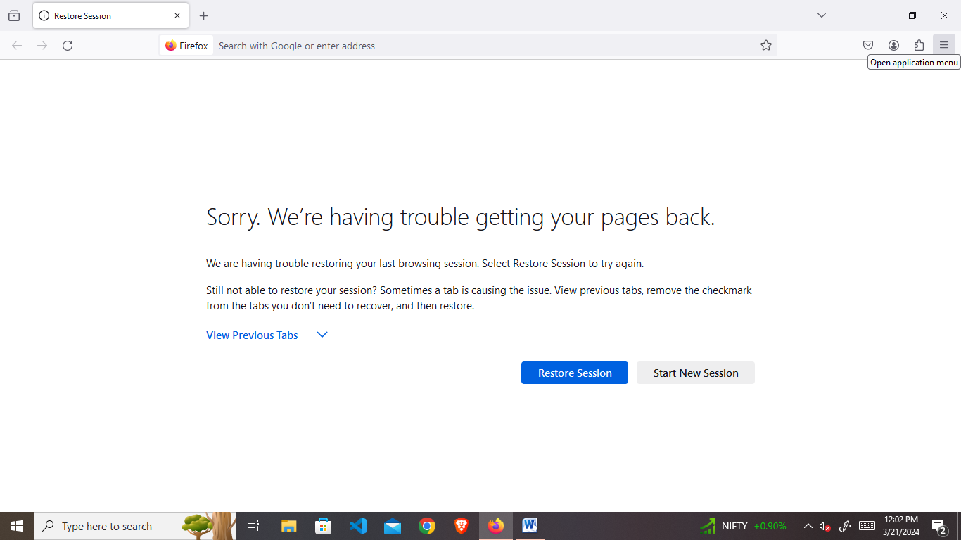

1. **Click on Add-ons and themes**

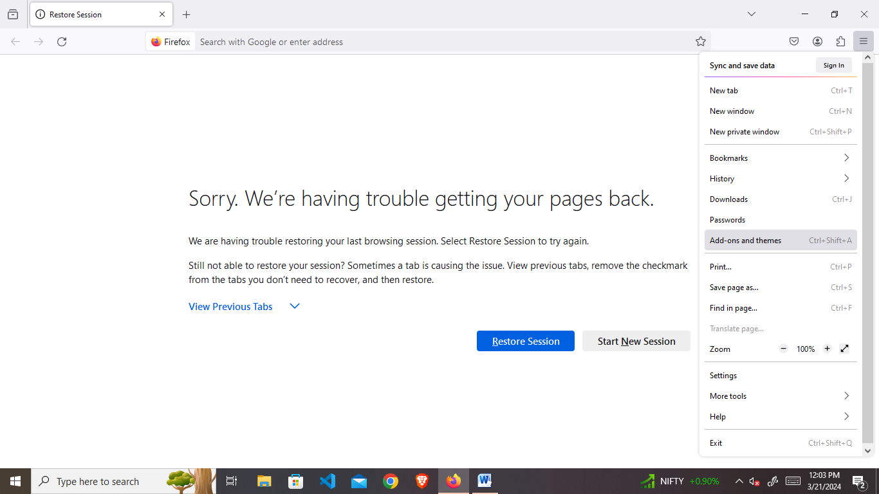

1. **Search Editthiscookie**

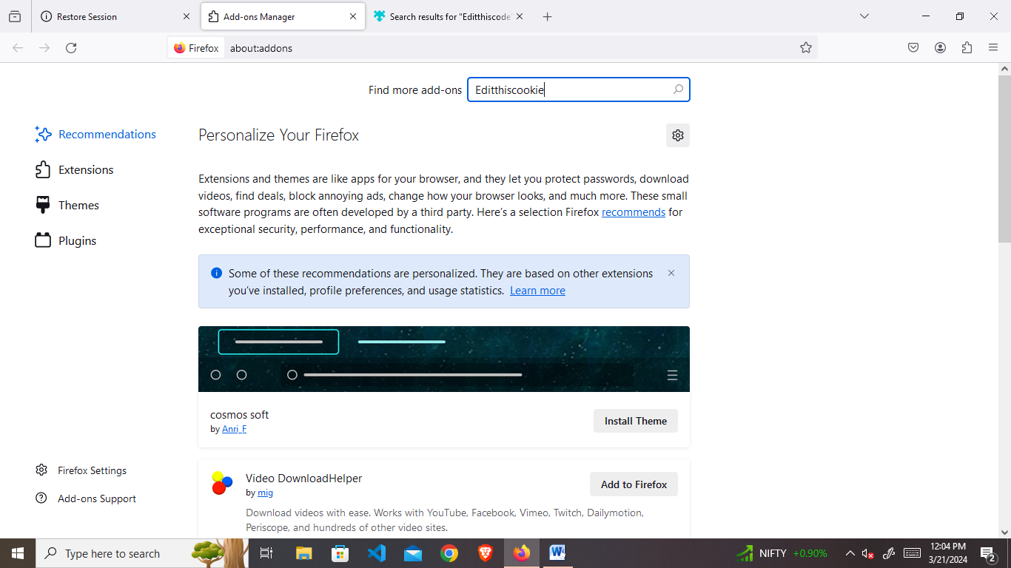

1. **Download EditThisCookie**

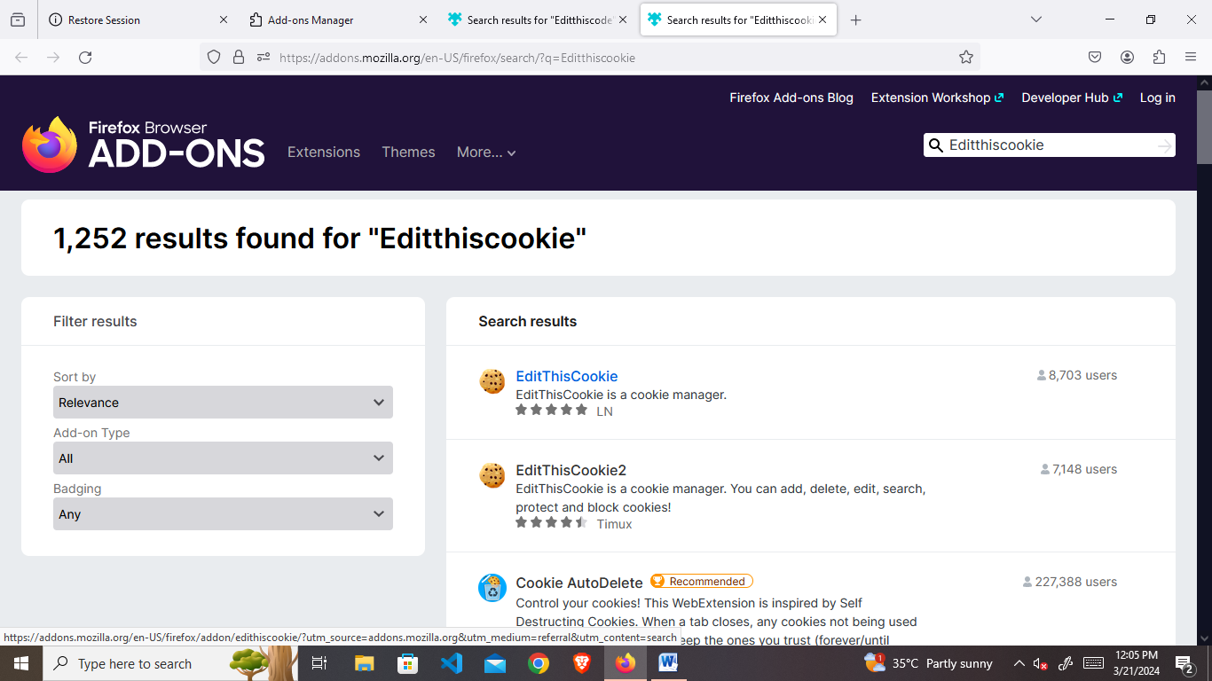

1. **Login any account like chatgpt and click on extension**

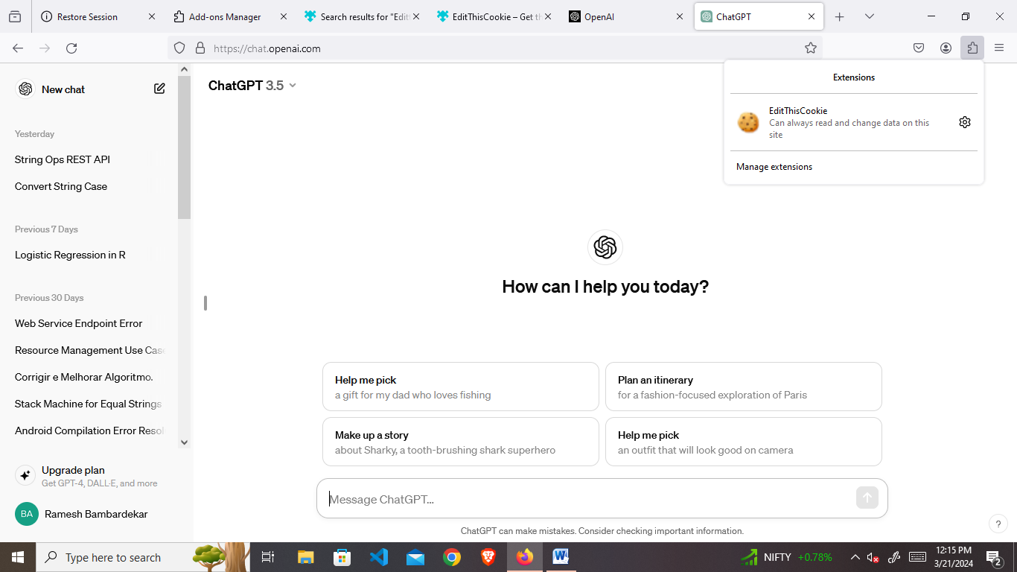

1. **Click on export button**

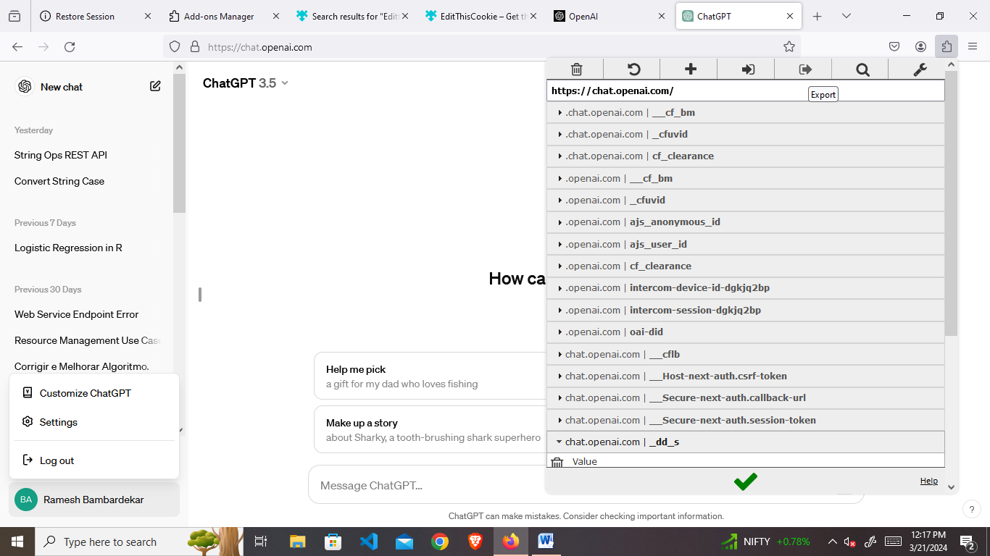

1. **Logout the account**

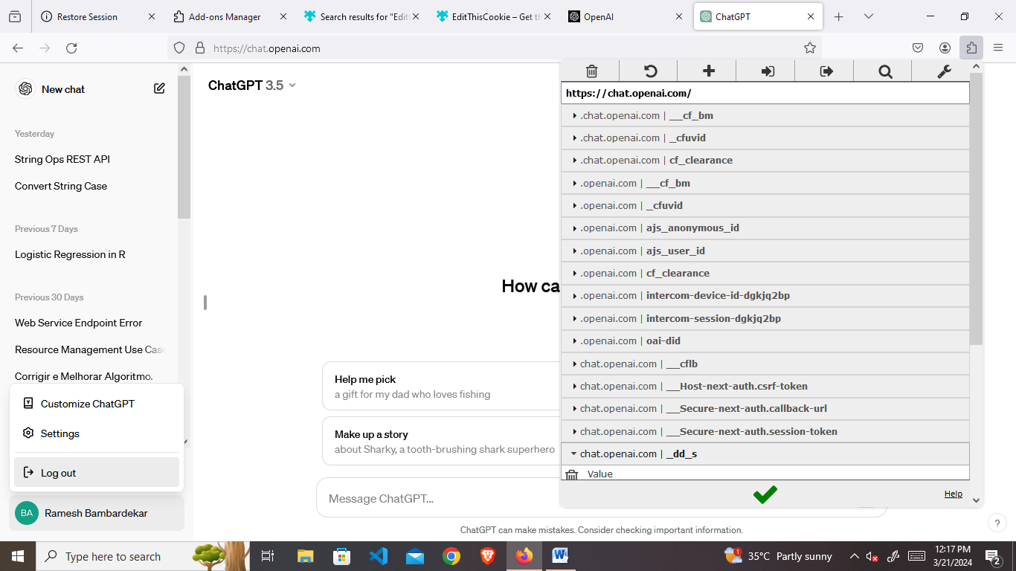

1. **Click on –extension –EditThisCookie –import**

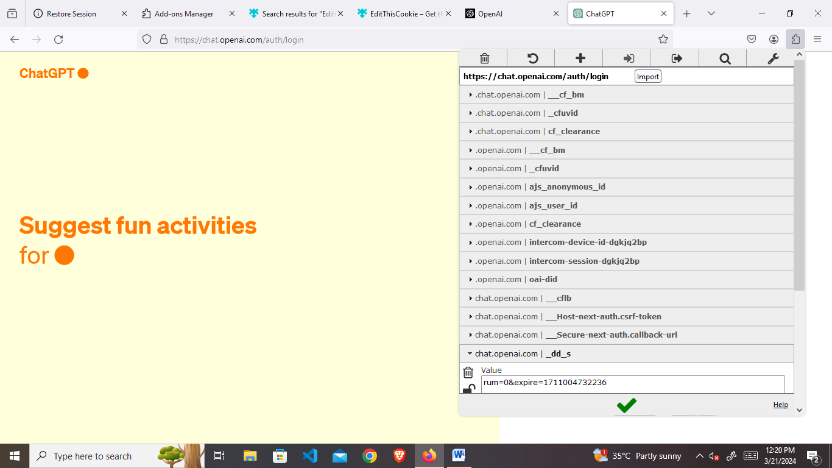

1. **Finally Click on Green tick then refresh the page**



